AMNESTY INTERNATIONAL
PUBLIC DOCUMENT

2 December 2014

Case studies of police torture in the Philippines

Alfreda Disbarro

Alfreda Disbarro was stopped by police on 3 October 2013 and accused of being a drug dealer, which she vehemently denied. Despite emptying her pockets to demonstrate she was not dealing drugs, she was taken to the Drug Enforcement Unit. Inside, an informal employee searched Alfreda but no illegal substance was found. An informal police auxiliary (“asset”) then placed a bottle of alcohol on top of Alfreda’s head and aimed his gun at it. “I was so afraid that I would get shot. I just closed my eyes in fear.”

He didn’t shoot, but then a more senior officer took her to another room. Alfreda told Amnesty International: “He said, ‘Can you take my kicks?’ I said, ‘No, sir.” He then kicked me so hard that I fell against the wall. He punched me continuously and hit me with the wooden baton. He punched me on the stomach. He hit me in the face four times. He poked my eyes with two of his fingers. He slapped me six times and slammed my head against the wall twice. He was forcing me to confess that I was a drug dealer...He took a mop and forced the dirty and damp rag at the bottom of the mop into my mouth. Then, he took it out and smeared my face with it.”

A different police officer then dragged Alfreda to another room and attacked her with a metal bar. He only stopped beating her when he accidentally hit his fingers against a locker. Throughout her ordeal, Alfreda was not allowed to contact her family. Her sister was finally able to visit her at 6.30 pm the next day in a dark room, after police warned her not to disclose what had happened.

Because of the beatings, Alfreda had difficulty moving and breathing. She said she could not eat and found it agonizing to even drink a glass of water. She told Amnesty International that ten days after her torture, her thighs shook each time she tried to urinate.

Jerryme Corre

“They started running towards me and pointed their guns at me. They forced me to lie face down on the floor, and someone hit my head with his gun. They kicked and punched me on the sides, neck, stomach and knees. I asked them, ‘Who are you? Are you the police? If you are police officers, tell me what my crime is. Do you have a warrant?’ But they only said I did not have the right to ask questions.”

The police accused Jerryme Corre of robbing and killing a foreigner and a police officer, which he strongly denied.

Jerryme told Amnesty International that at least 10 unknown and armed men in plain clothes arrived on motorcycles. “They handcuffed me and dragged me to the local police station 500 meters away.”

Once inside the police station, more men in plain clothes, whom Jerryme also believed to be police officers, took turns beating him overnight. They blindfolded him and started hitting the soles of his feet with a wooden baton, and continued kicking and punching him. At one point, one of the officers became concerned that he would be able to identify them, so they took off his denim shorts and put them over his head, tightening the waistband around his neck with a cord, and doing the same thing above his head. They then cuffed his ankles together. “They put a piece of cloth over my mouth and then they poured water down my throat for what seemed like a very long time until I felt I was drowning and could no longer breathe. Then, they would ask the same questions and poured water again and again and again… so many times. I could not gulp down all of that water and tried my best to close my mouth.”
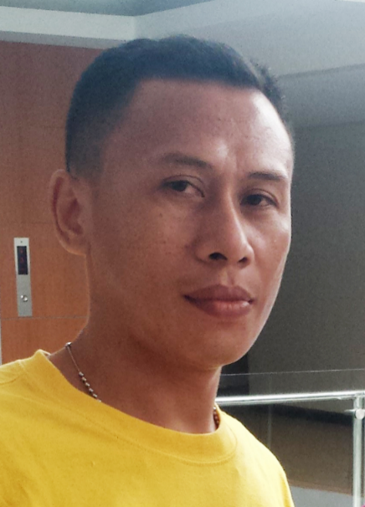
He was then given electric shocks to force him to confess. “They repeated zapping my body with electricity and threatening me many times – I think around 20 times. A few hours later—I was lying down, no longer having the strength to stand up—they drenched my body with water and gave me electric shocks again and again. I could not see them, but I could hear their voices. I will never forget those voices.”

A local community leader told the police that they arrested the wrong person but the police refused to believe him.

Later that day, Jerryme was forced to sign a document which he was not permitted to read and was taken to the house of a prosecutor. On the way, the police produced a 1,000-peso note and a small plastic sachet. The next day Jerryme was informed that the police were filing drug charges against him.

Jerryme told Amnesty International that he was taken to a hospital for examination eight days after his arrest and torture. He said that the doctor did not perform a physical examination, and that in any case most of his bruises had healed by then. When he was transferred to the Angeles District Jail, his wife complained to the Philippines’ Commission on Human Rights. They conducted a medical examination and found marks on Jerryme’s body consistent with torture.

Jonathan (not his real name)

‘Jonathan’ was 17 when he was arrested with his friend after they had been caught stealing from two women in a crowded street. Jonathan told Amnesty International that several people beat them up, punched them and hit them with a child’s scooter. Inside the police station, Jonathan said that a police officer poked him with a sharpened pencil in the chest. He said that four policemen punched him in the stomach, on the sides and in the ribs, despite having been informed that he was only 17 and therefore a child. Jonathan said he heard one of the policemen say, “Let’s kill them”. He thinks that the police did not kill them only because it would have been witnessed by a village security officer. Jonathan was forced to “confess” that he had stabbed one of the women he had stolen from. And the beatings continued.

“I really can’t forget the beatings we suffered at the hands of the policemen… I feel like crying whenever I remember that. I used to want to be a policeman when I grow up, but seeing how they operate, I have now given up on that dream. I can’t forget what they did to me. I will never forget.”

Darius Evangelista

On 5 March 2010, police officers arrested Darius Evangelista on suspicion of robbery in Manila. Court documents obtained by Amnesty International quoted witnesses describing police officers in plain clothes taking Darius into a police station in Tondo, Manila. Fellow detainees said they heard him moaning in pain and later saw him being carried out of the small room with packing tape around his eyes. They also heard a senior police officer say, “finish him off”. Darius was never seen alive again.
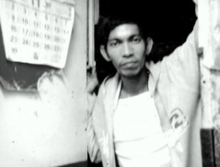
Three days after Darius’ disappearance, his father received reports that a decapitated head was seen floating on Manila Bay. Darius’ father and wife both recognized Darius’ face when they saw the head at the police station. By the time the prosecution managed to arrange for DNA examination of the skull, local crime laboratories could no longer positively identify if the skull belonged to Darius as they did not have the facilities to conduct a thorough DNA test.

Five months later, a harrowing video was broadcast on national and international television. It shows Darius lying naked on the floor, screaming and writhing in pain while a man holds a string attached to Darius’ penis and forcefully pulls it several times. Others, including uniformed police officers, are visible watching this taking place. In response to the media frenzy that followed the release of the video, the Philippine National Police conducted its own investigation which resulted in a report that absolved all but three of the police officers involved.

On 22 August 2011, the Department of Justice prosecutor found a prima facie case for torture committed by means of conspiracy against seven police officers. Three of the police officers accused in the court case surrendered to the police in 2012 and 2014, and police arrested the primary suspect in 2013. All of them have pleaded not guilty. The other suspects remain at large. More than four years after the incident – and almost three years after the prosecution began – the court case is ongoing.

Torture for entertainment - wheel of torture

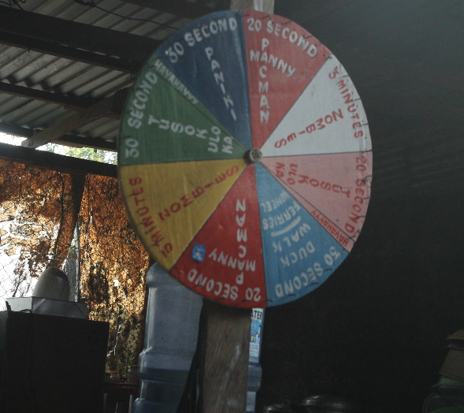
In January 2014, the Philippines’ Commission on Human Rights (CHR) exposed a secret detention facility in Laguna, a province south of the capital, Manila, in which police officers appeared to be torturing detainees for entertainment. The CHR found a large roulette wheel on which were written descriptions of various torture positions. If the wheel was spun and landed on “30 second bat position”, this meant that the detainee would be hung upside down (like a bat) for 30 seconds. “20 second Manny Pacquiao” meant that a detainee would be punched non-stop for 20 seconds. The existence of such a device, apparently for police officers’ entertainment, clearly demonstrates the casual attitude towards torture within the police force.

